**OUTPUT:**

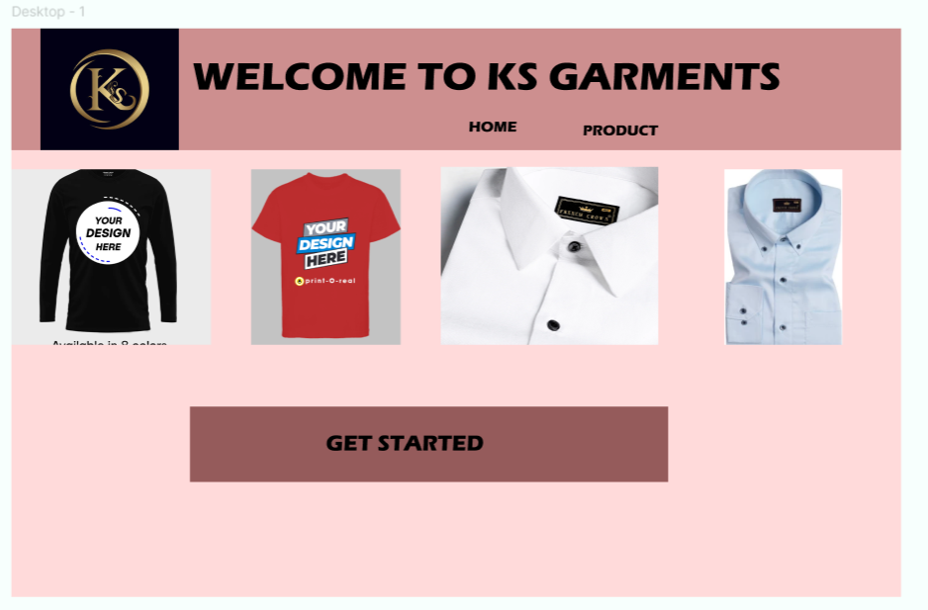

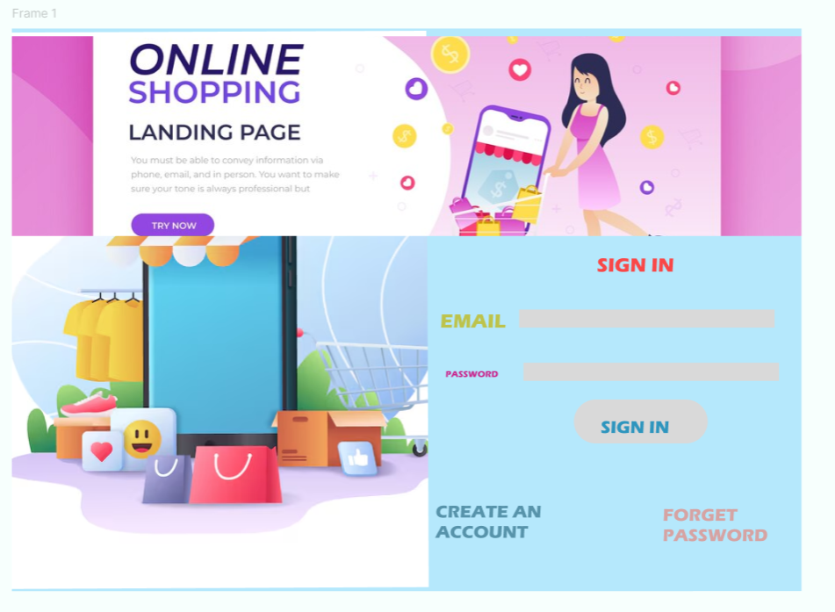

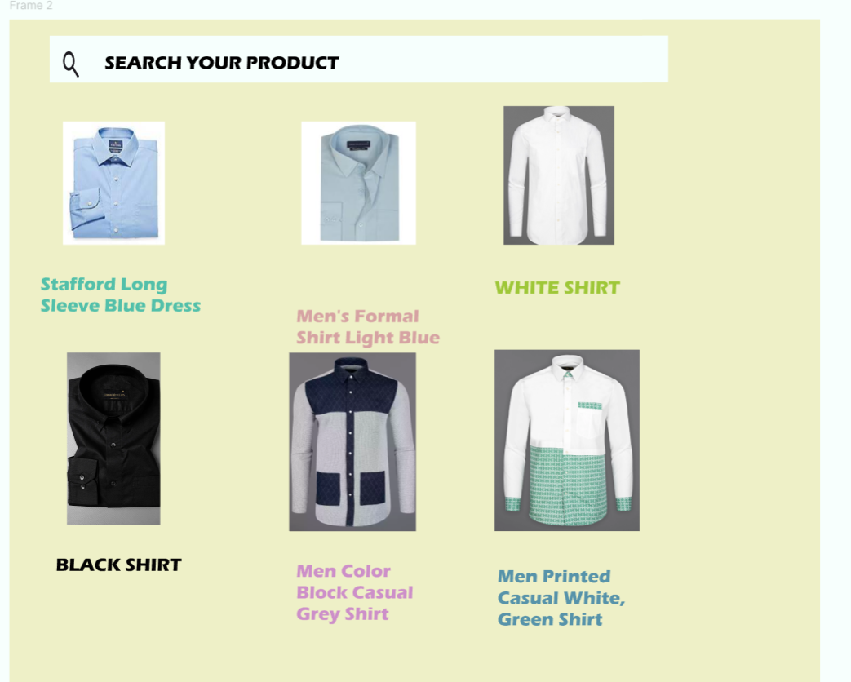

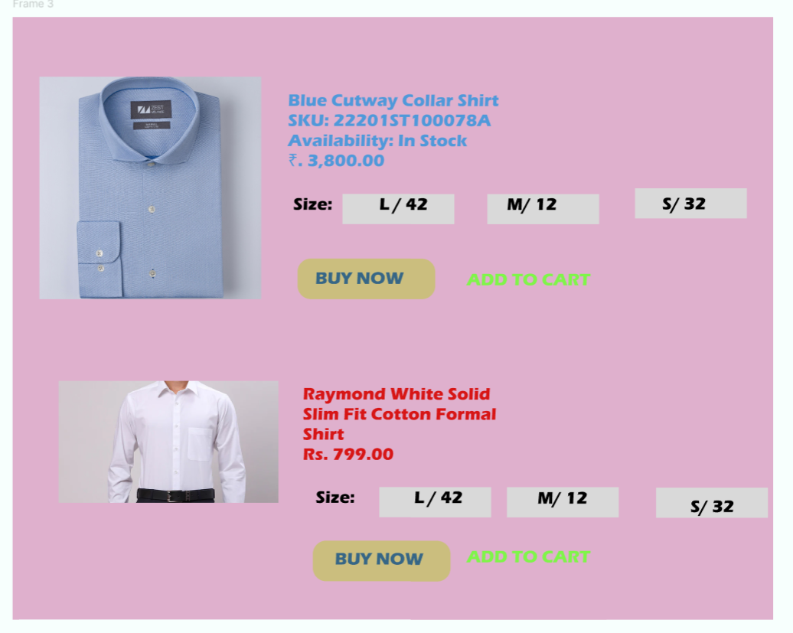

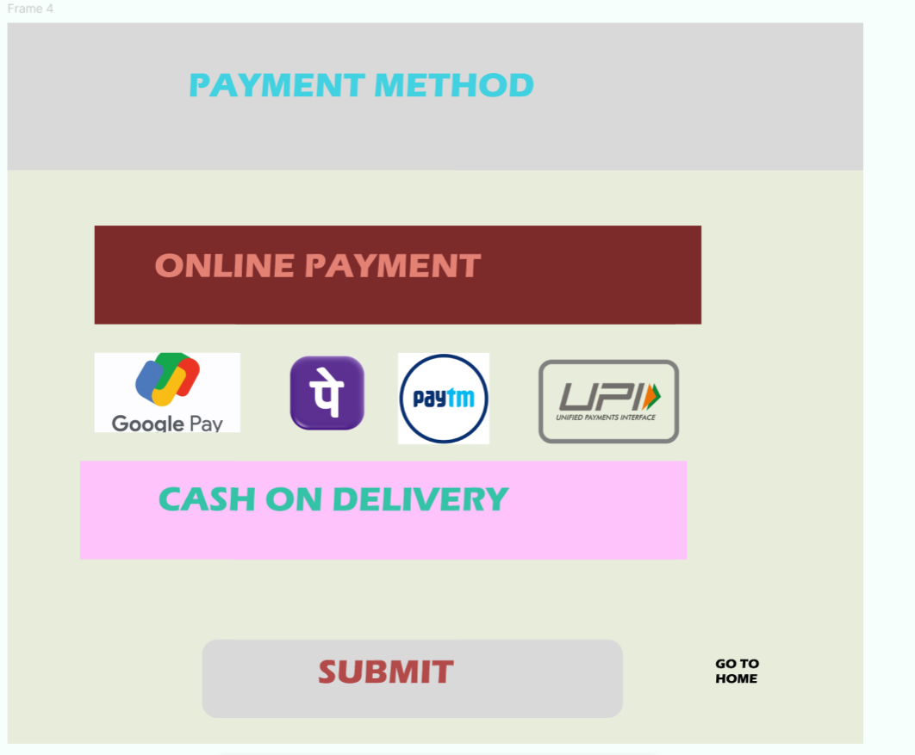

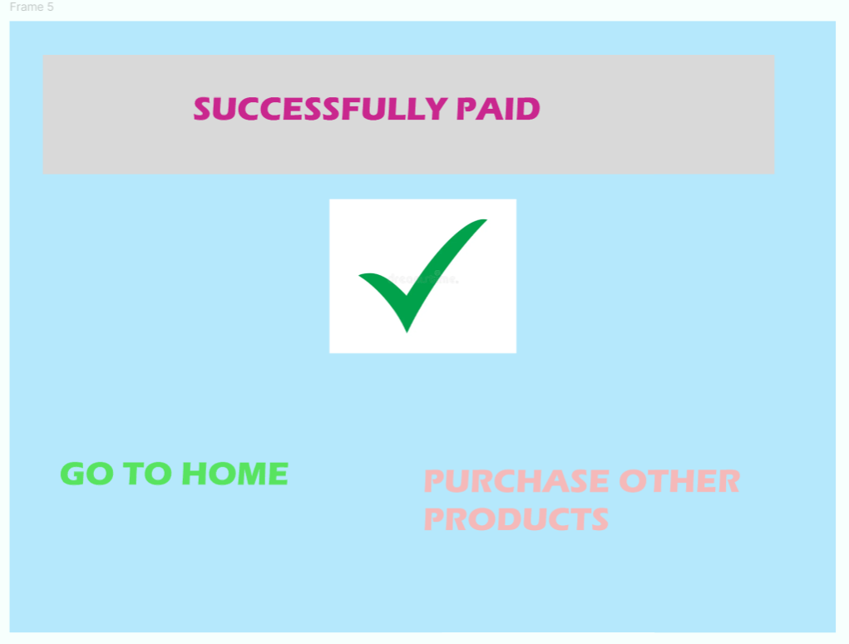

**SURVEY AND FEEDBACK FORM:**

**Customer information:**

**Clothes purchased:**

**Overall customer experience:**

**Customer rating:**

**Packing of products:**

**Men’s clothes:**

**Output:**

**Flow diagram:**

**Flow mapping:**

